Full Title of Your Abstract 题目，大写每一个实词

Minying Wang¹, Kunwei Liu², Zizhen Gong³ (名全拼+姓全拼，通讯作者用下划线表示，斜体)

¹Department of Xxx, University of Xxx, City 123456, Country;
²Department of Xxx, University of Xxx, City 123457, Country;
³Department of Xxx, University of Xxx, City 123458, Country

A single paragraph of about 200-350 words. For research articles, abstracts should give a pertinent overview of the work. We strongly encourage authors to use the following style of structured abstracts, with or without headings: 1) Background/Objectives: Place the question addressed in a broad context and highlight the purpose of the study; 2) Methods: Describe briefly the main methods or treatments applied; 3) Results: Summarize the article's main findings; and 4) Conclusions: Indicate the main conclusions or interpretations. The abstract should be an objective representation of the article, it must not contain results which are not presented and substantiated in the main text and should not exaggerate the main conclusions.

Acknowledgement: (If any please state your acknowledgement here) This work was supported by the National Natural Science Foundation of China (Grants No. xxxx).

总篇幅300-350单词以内

案例1
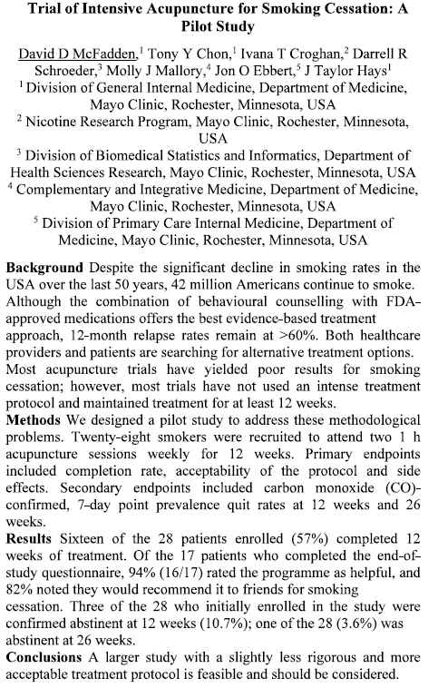

案例2
